**KT Document for DevOps**

|  |  |
| --- | --- |
| Document Type | KT Document |
| Document # | DevOps_V1.0 |
| Service Provider | MicroGrid Inc. |
| Document Date | Dec 2023 |
| Document Version | Version 1.0 |

|  |  |
| --- | --- |
| Srinivas Negi R | Ananth Raj Polamarasetty |
| MicroGrid – Jr DevOps Engineer | MicroGrid – Product Owner |
| **Prepared & Reviewed by** | **Approved by** |

Table of Contents

1. GCP Project Creation 3

2. Enable API Services 6

3. Cloud Function Creation 9

4. VM Instance Creation 14

5.  APP Engine Deployment 9

# GCP Project Creation

# Enabling API services

To enable APIs in the Google Cloud Console, you can follow these steps:

1. Go to the Google Cloud Console: <https://console.cloud.google.com/>
2. Select your project from the project selector dropdown at the top of the page.
3. Click on the menu icon (☰) on the upper-left corner of the console to open the navigation menu.
4. Scroll down and click on "APIs & Services" to expand the section.
5. In the "APIs & Services" section, select "Library."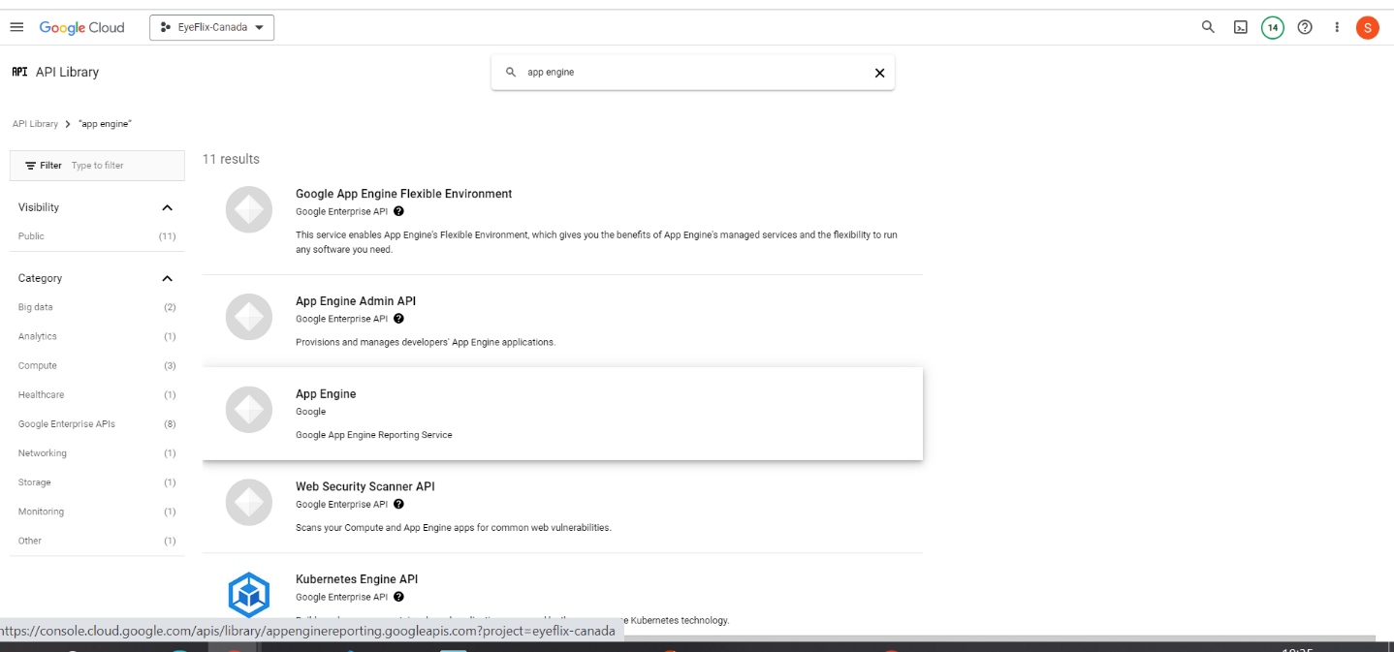

Option 1: Enabling Individual APIs:

6. In the "Library" page, you will see a list of available APIs. Use the search bar or scroll to find the API you want to enable.

1. Click on the API you want to enable.
2. On the API details page, click on the "Enable" button.
3. Wait for the API to be enabled. This process may take a few moments.

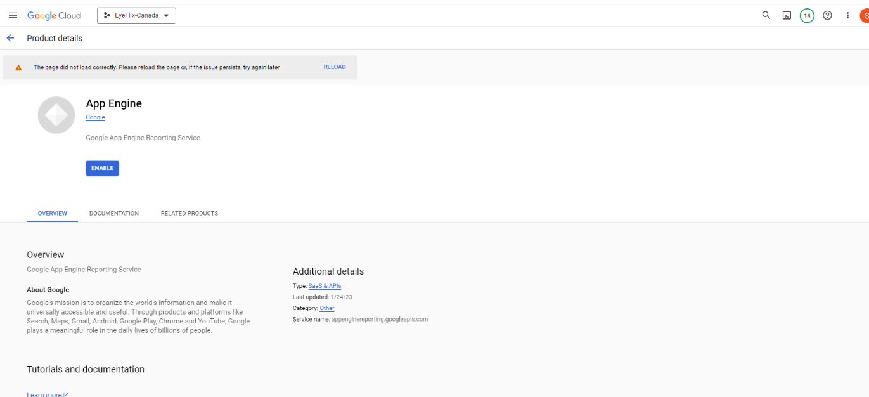

Option 2: Enabling Multiple APIs:

6. In the "Library" page, you will see a list of available APIs. You can use the search bar or scroll to find the APIs you want to enable.

1. Click on the checkboxes next to the APIs you want to enable.
2. Once you have selected the desired APIs, click on the "Enable" button at the top of the page.
3. Wait for the selected APIs to be enabled. This process may take a few moments.

After enabling the APIs, you can start using the corresponding services and features in your project.

1. Cloud Function Creation
2. Access the cloud console and go to cloud functions service from the project.

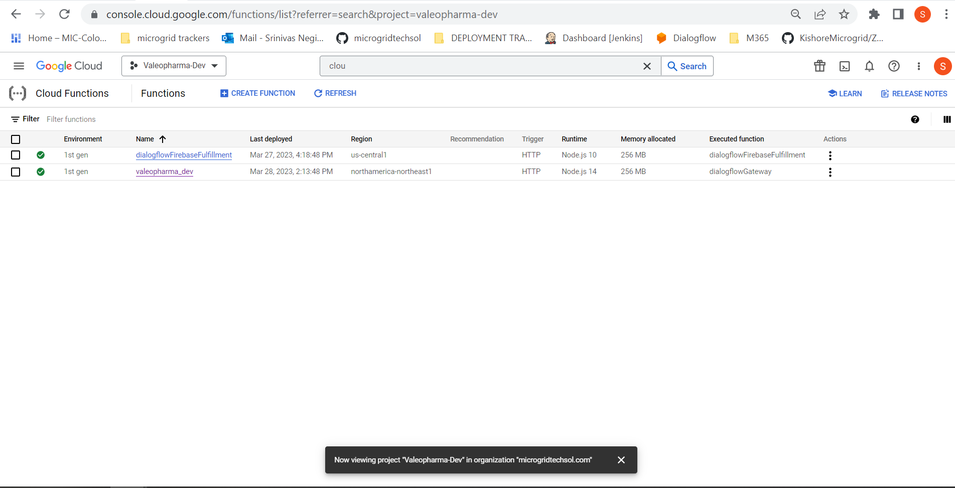

1. Click on the create cloud function.

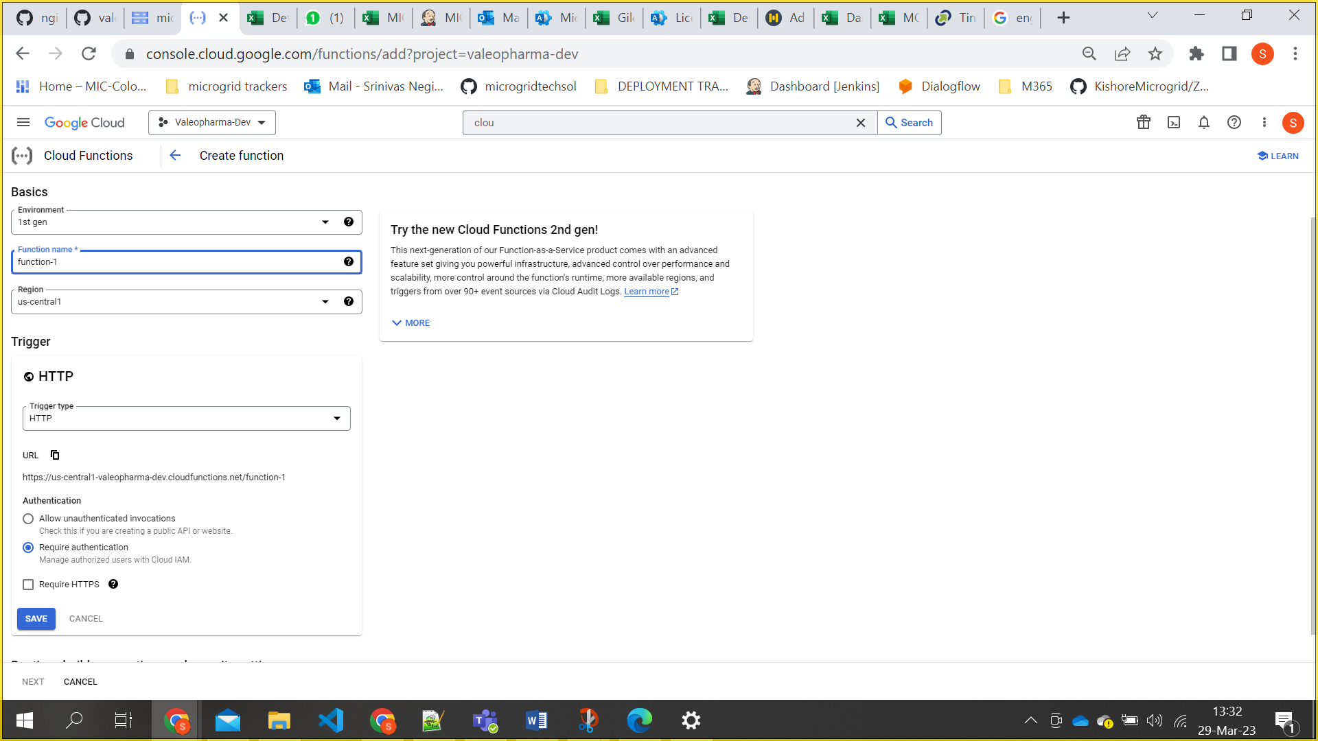

1. Here we have to follow the naming convention for Function name. [projectname_env]
2. Region need to selected according to project.
3. Uncheck the Request HTTPS and click on save button.

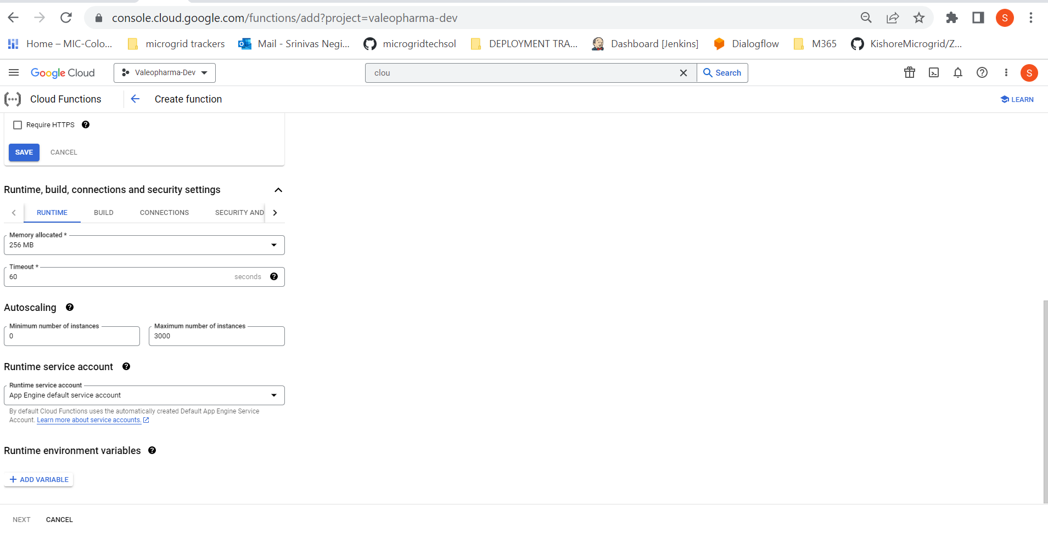

1. Change the maximum instance number from 3000 to 1000 and click on next button.

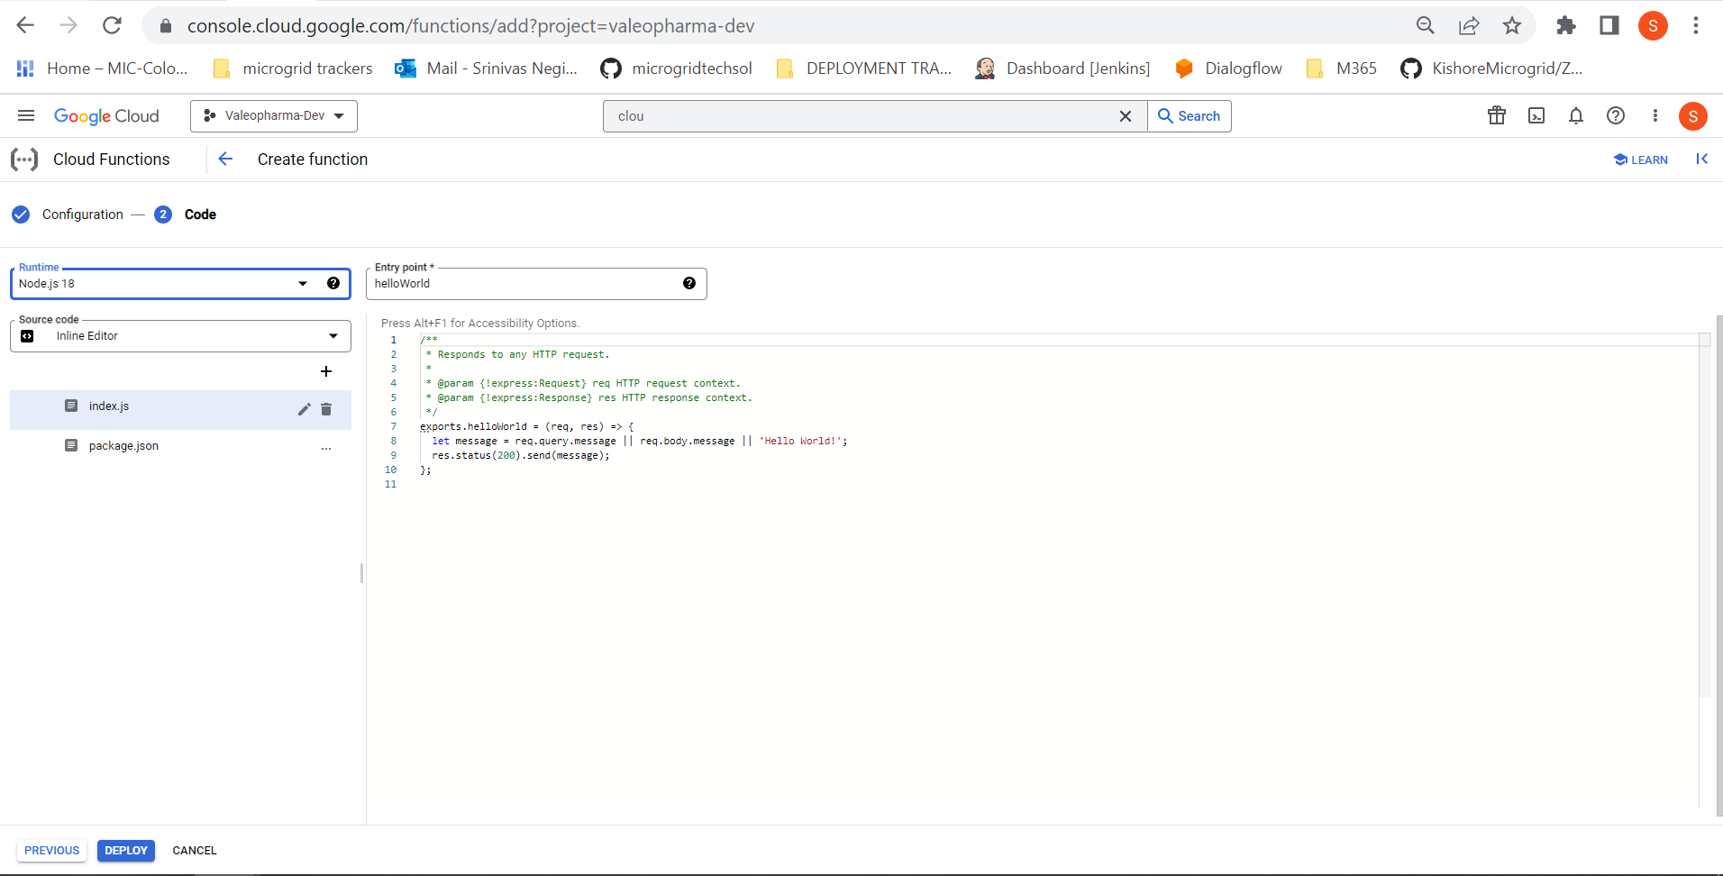

1. We need to select runtime that what we are using.
2. Entry point name is dialogflowGateway.
3. Generate a service account key as json file and copy the code and paste in index.js along with given code. Please find the index.js and package.json files in the folder and place them as is it is by changing project details which will be provided in key.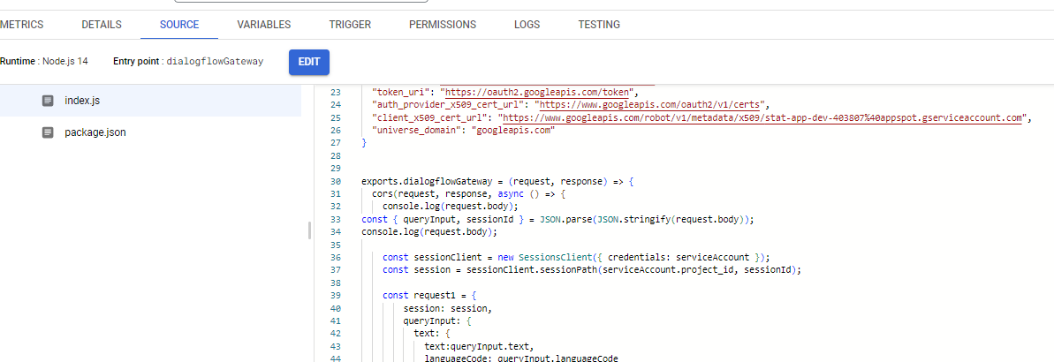
4. Now click on deploy.
5. After cloud function deployed we need to give all user permissions for the cloud function and need to give permissions for service account.
6. All user permissions means, Everyone can access 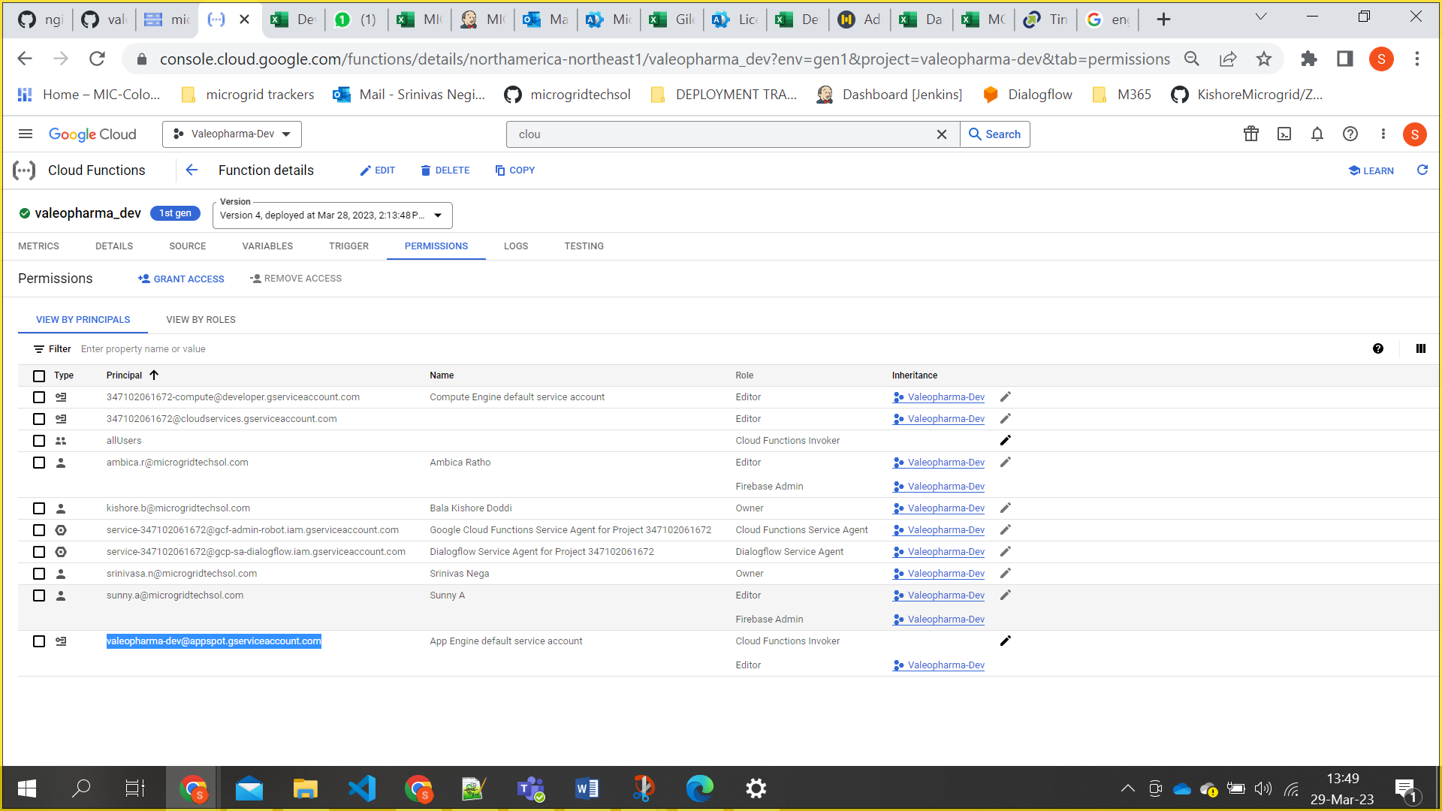

# VM INSTANCES CREATION:

1. Log in to Google Cloud Console: Open your web browser and go to the Google Cloud Console. Log in with your Google Cloud account.
2. Select a Project: If you have multiple projects, select the project where you want to create the VM from the project dropdown menu in the top bar.
3. Navigate to Compute Engine:In the left navigation pane, click on "Compute Engine" under the "Compute" section.
4. Create a new VM instance: Click the "Create" button to create a new VM instance.

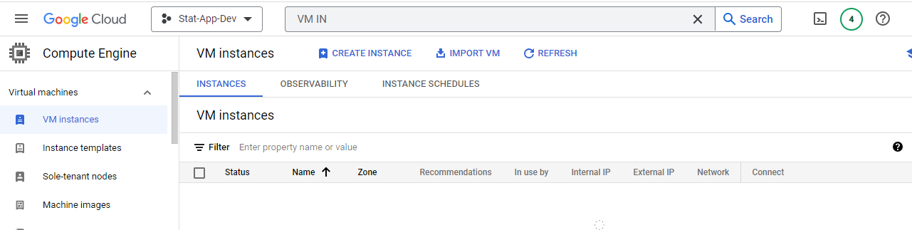

1. Fill in the required information in the "Create an instance" page, including:
2. Name: Give your VM instance a name.
3. Region and Zone: Choose the region and zone where you want to deploy your VM.
4. Machine type: Select the desired machine type based on your resource requirements.
5. Boot disk: Choose an operating system for your VM, and set the size of the boot disk.
6. Identity and API access: Set the service account and access scopes if needed.
7. Firewall: Configure firewall rules to control incoming and outgoing traffic.

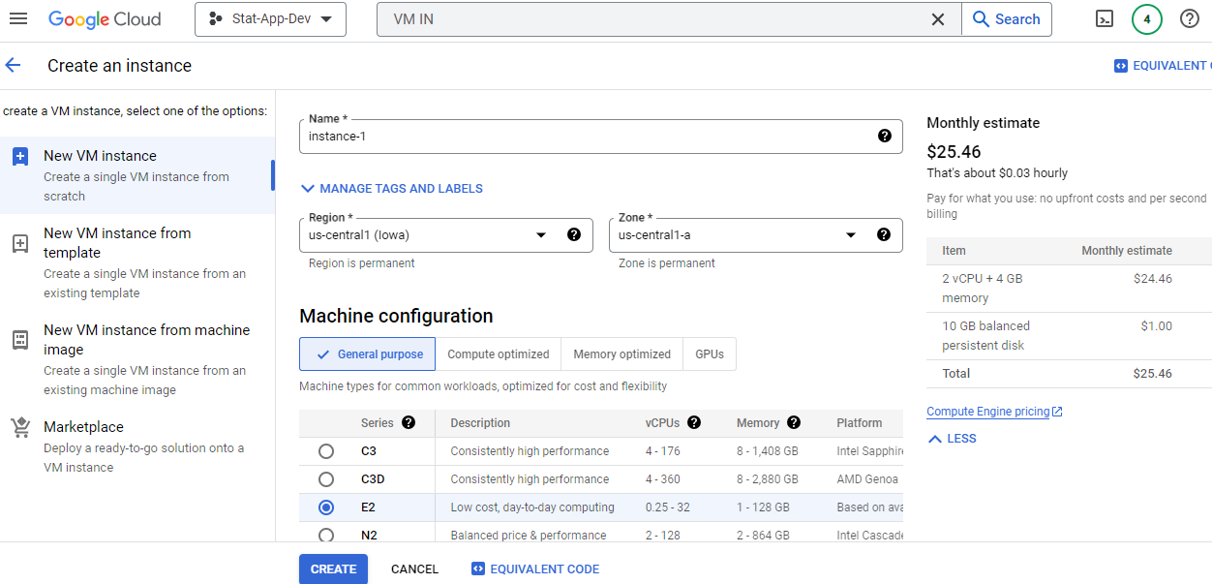

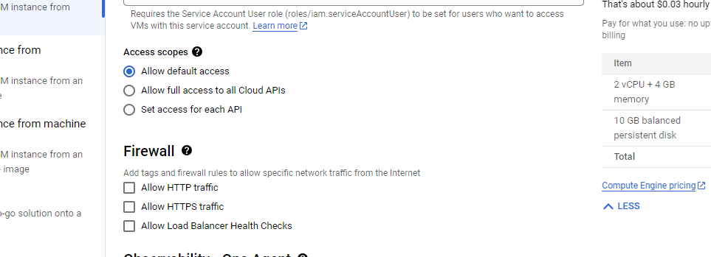

1. Advanced configurations (optional):
2. Expand the "Management, security, disks, networking, sole tenancy" section to access more advanced configurations.
3. Adjust settings such as automatic restart, deletion protection, and custom metadata.
4. Networking (optional):
5. Configure networking settings, such as specifying a network, subnetwork, and external IP address.
6. Click "Create":
7. Once you have configured all the necessary settings, click the "Create" button at the bottom of the page.

To create a new VM instance using a snapshot in Google Cloud Platform (GCP), please follow these steps:

1. Go to the Google Cloud Console ([https://console.cloud.google.com](https://console.cloud.google.com/)) and navigate to the project where you want to create the new instance.
2. In the Cloud Console, click on "Compute Engine" in the sidebar to access the Compute Engine section.
3. Click on "Snapshots" in the sidebar to see a list of your snapshots.

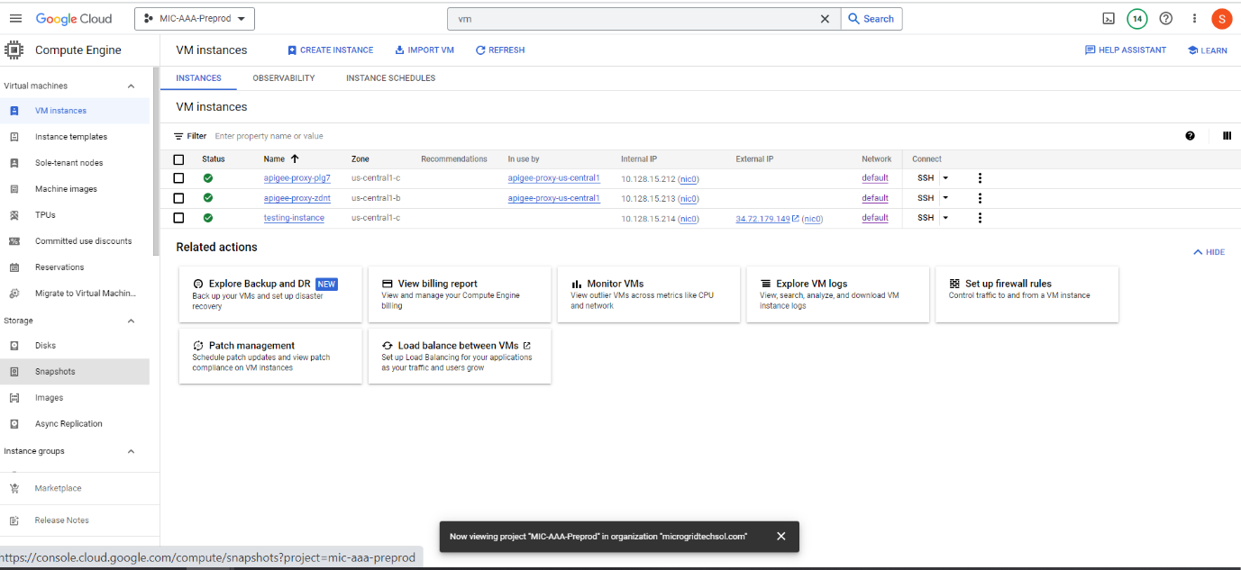

1. Identify the snapshot you want to use for creating the new instance and make note of its name.
2. Click on "VM instances" in the sidebar to go back to the VM instances view.

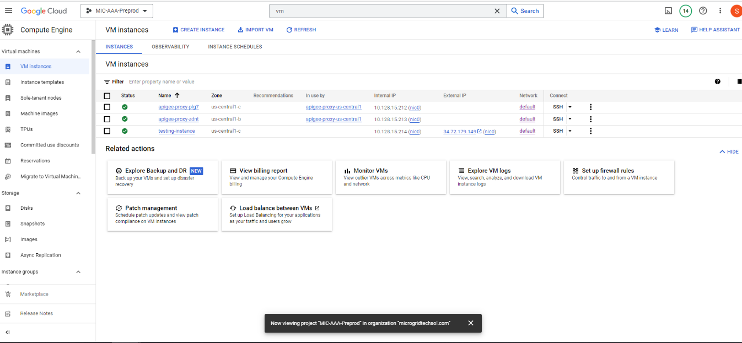

1. Click on the "Create" button to start the process of creating a new VM instance.
2. In the "Create an instance" page, provide the necessary details for your new instance such as name, region, machine type, and other configuration options.

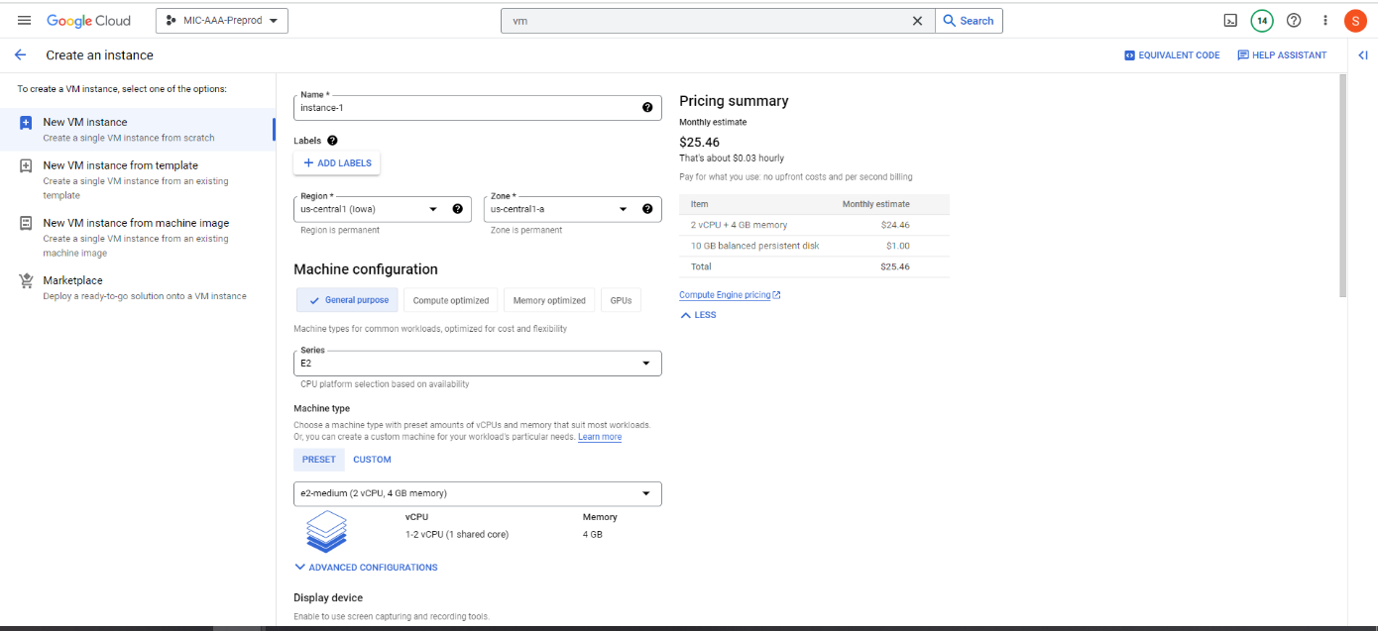

1. Scroll down to the "Boot disk" section and click on "Change" to select the boot disk.
2. In the "Boot disk" dialog, click on the "Snapshots" tab.

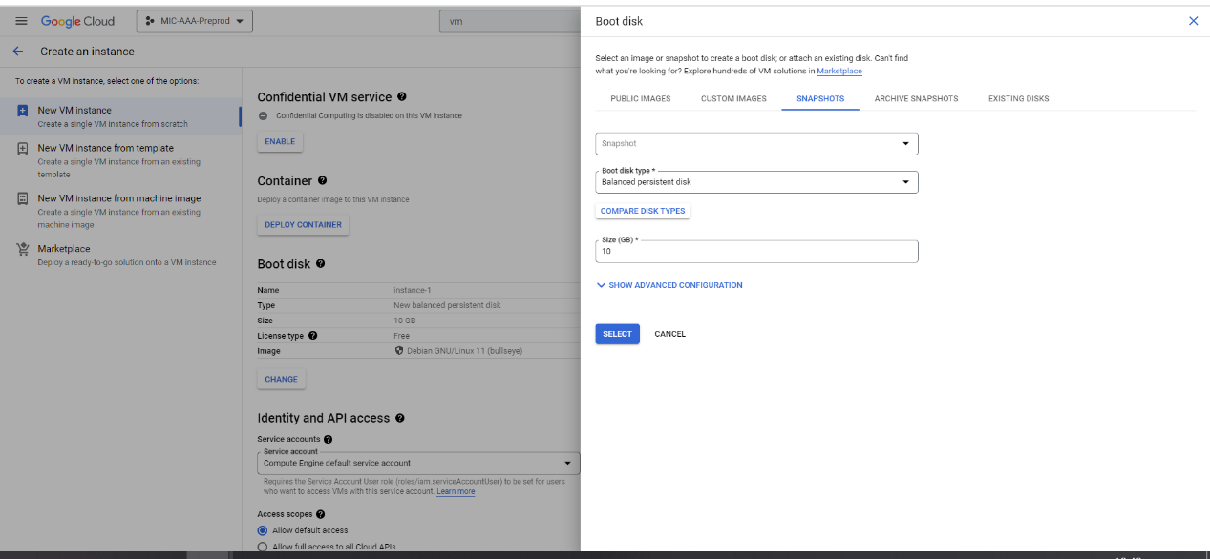

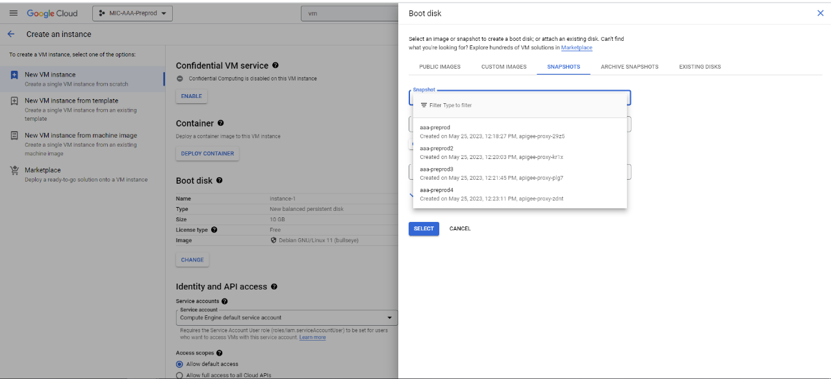

1. In the list of snapshots, select the snapshot you noted earlier.
2. Configure any additional settings for your new instance, such as networking, tags, and metadata.
3. Click on the "Create" button to create the new VM instance using the selected snapshot.

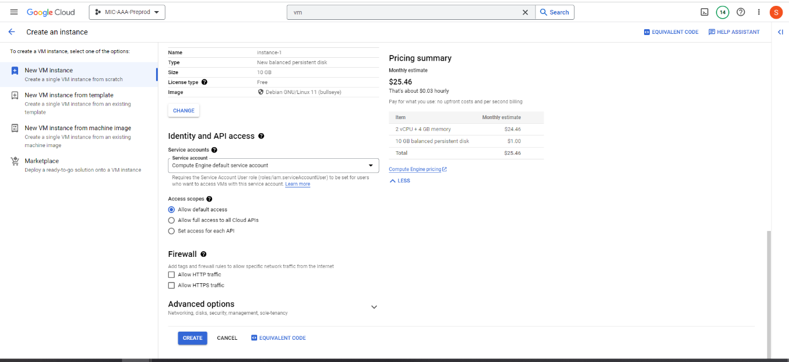

1. App Engine Deployment
2. To deploy the app engine service the source code is available in git.

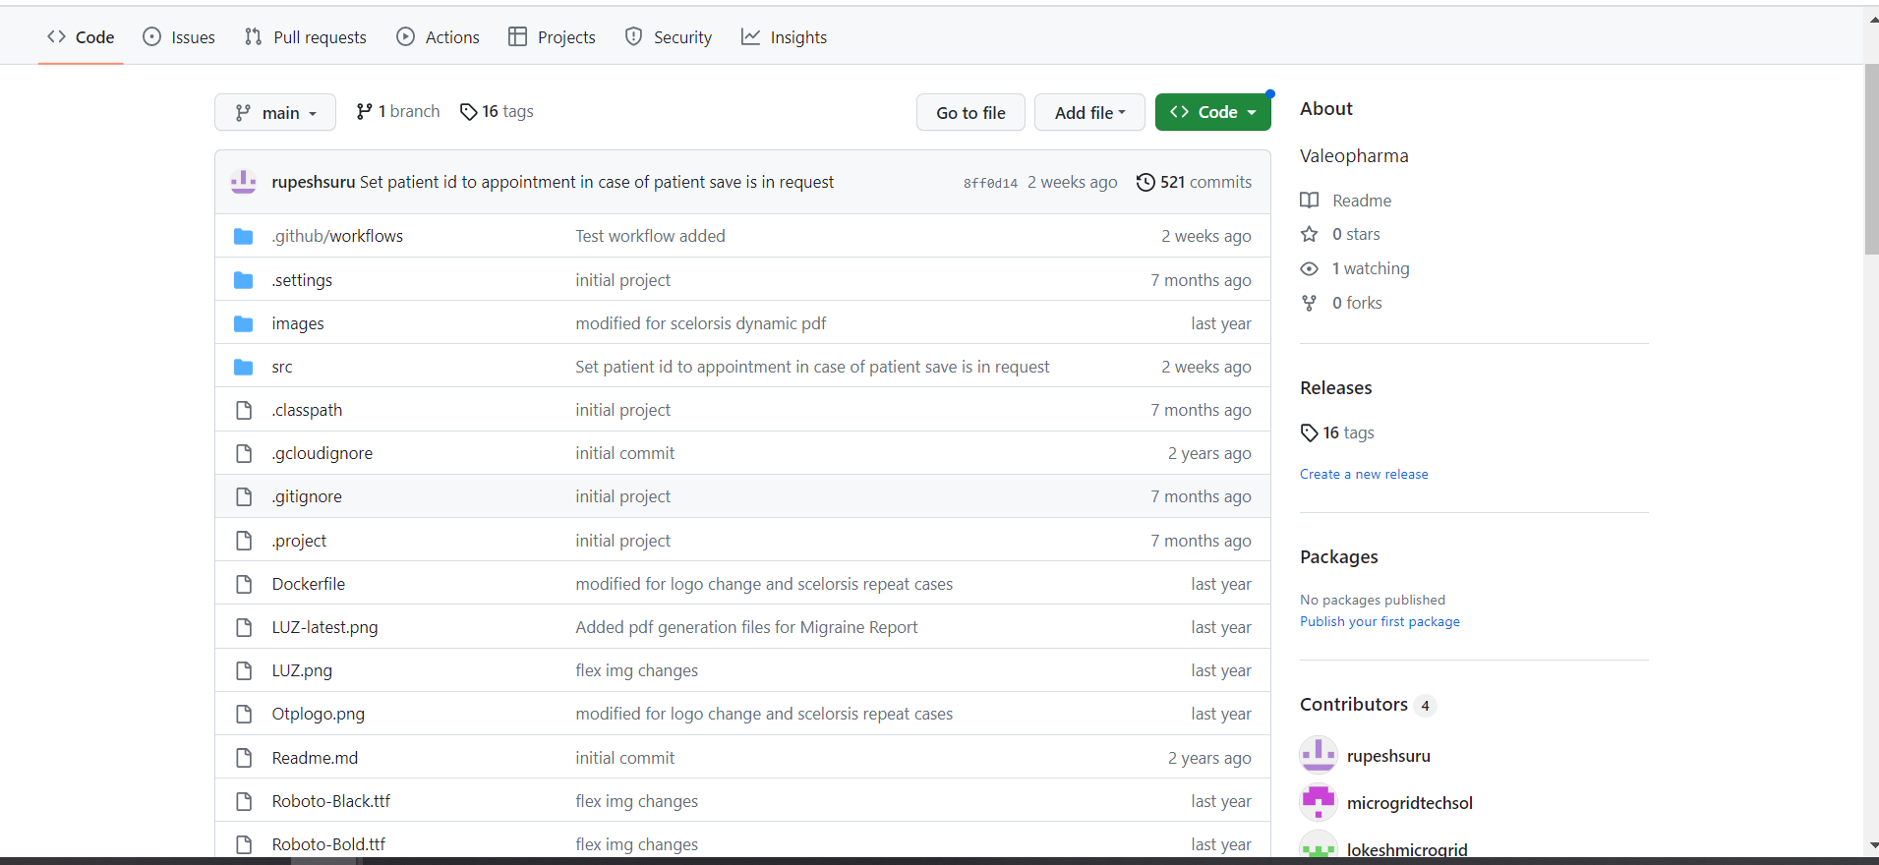

1. Compile the code and connect to the Google cloud project. Then deploy with the configured yaml file.
2. Otherwise we can deploy with Jenkins builds which already configured.

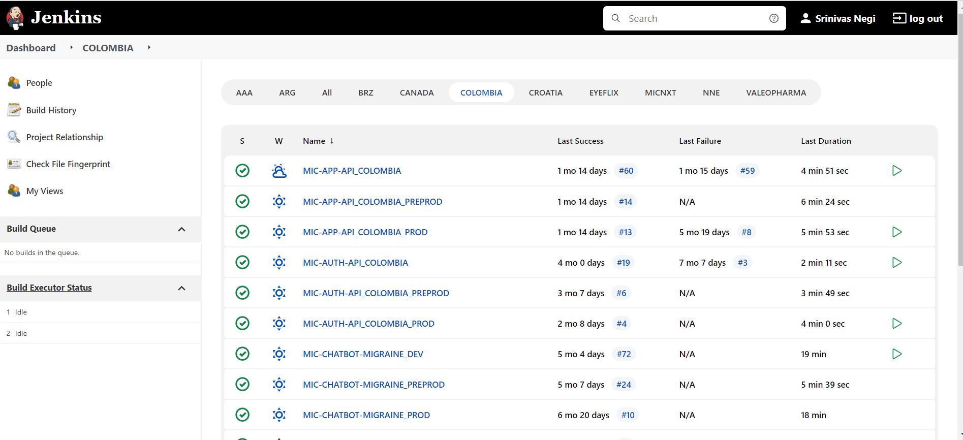

1. CLOUD STORAGE BUCKET:
   1. Access the cloud console and go to cloud storage service from the project.

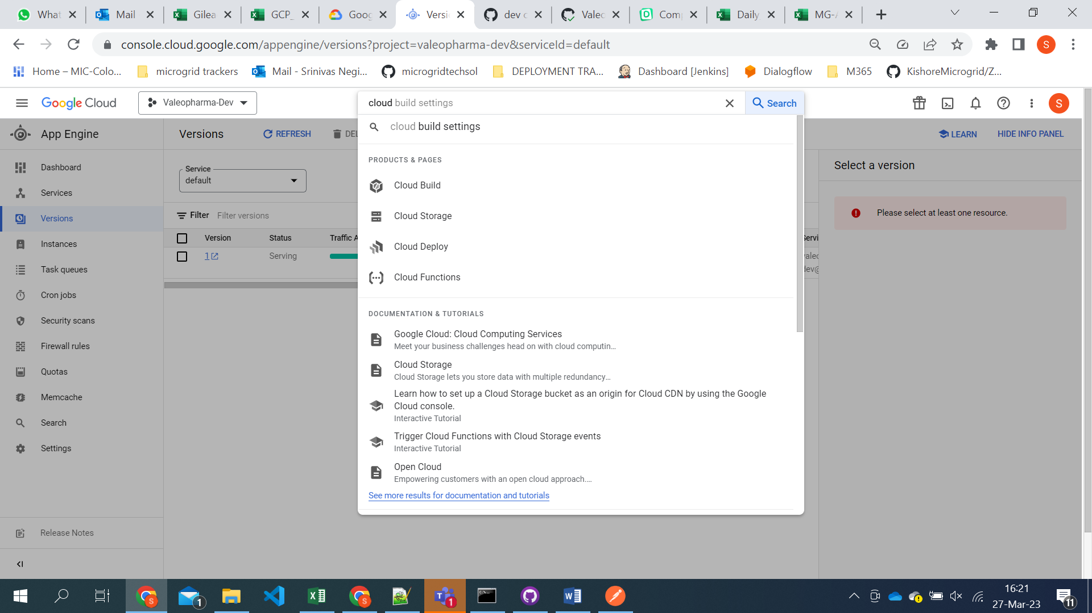

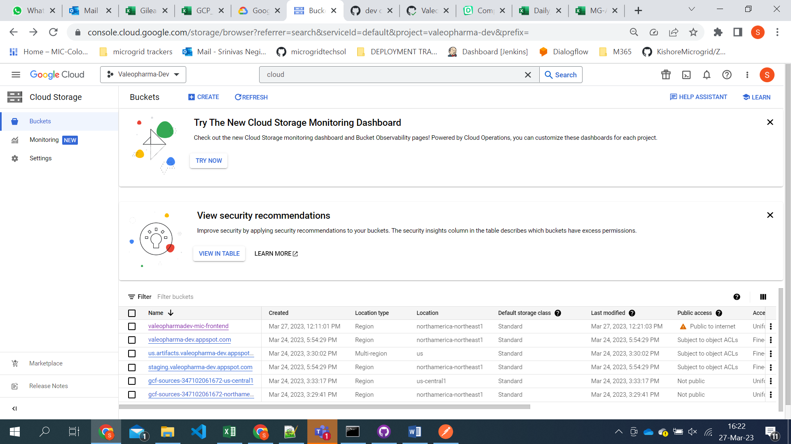

* 1. Click on the create

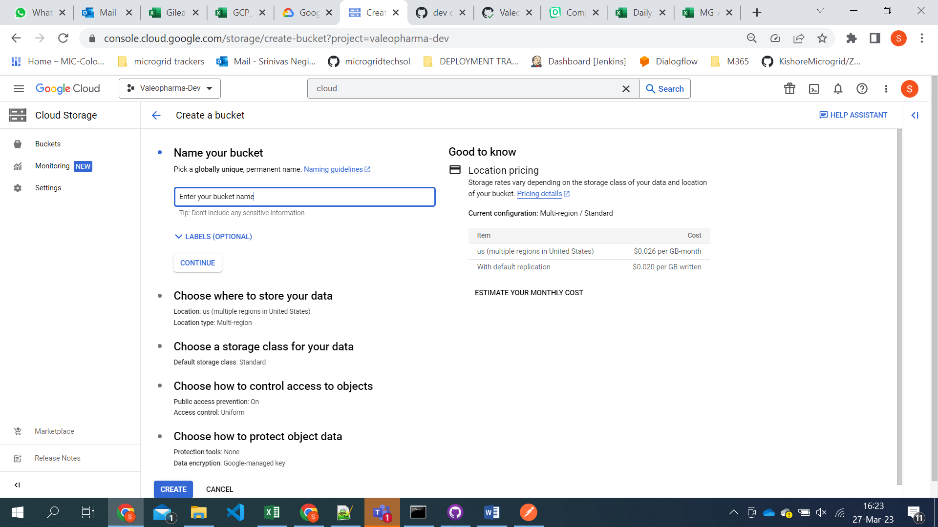

* 1. Select the region you want to store

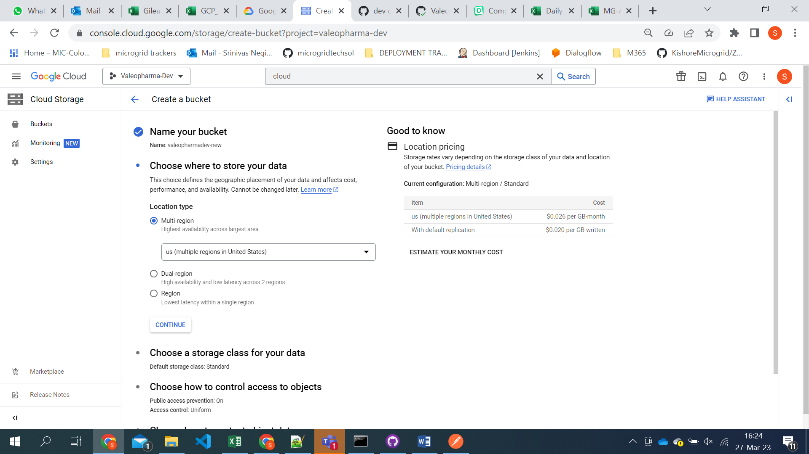

* 1. Choose the storage class

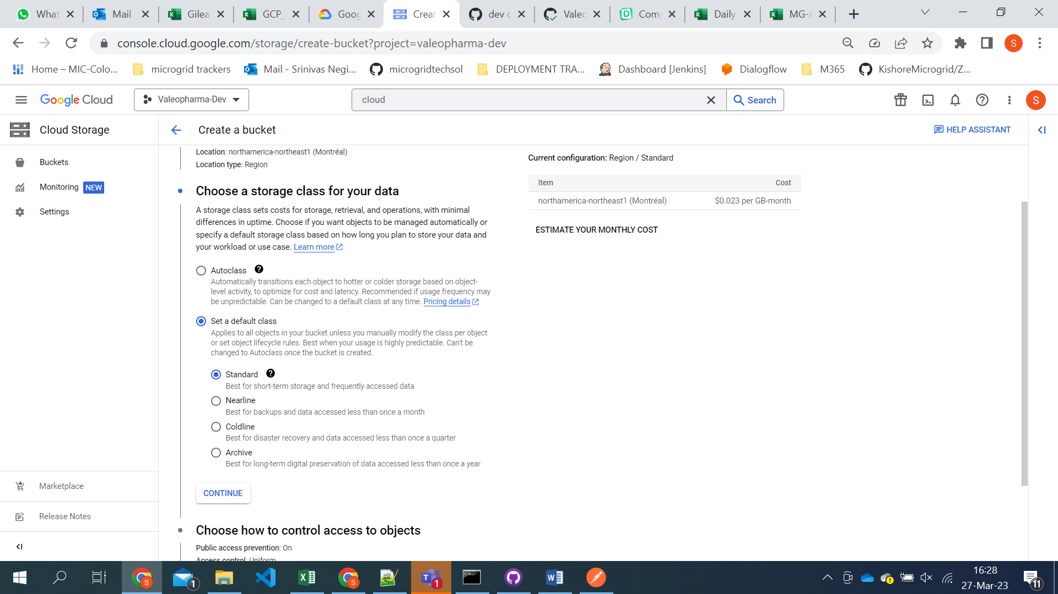

* 1. Click on the create button and new bucket will be created.
  2. Now we need to give all users permissions for the bucket.

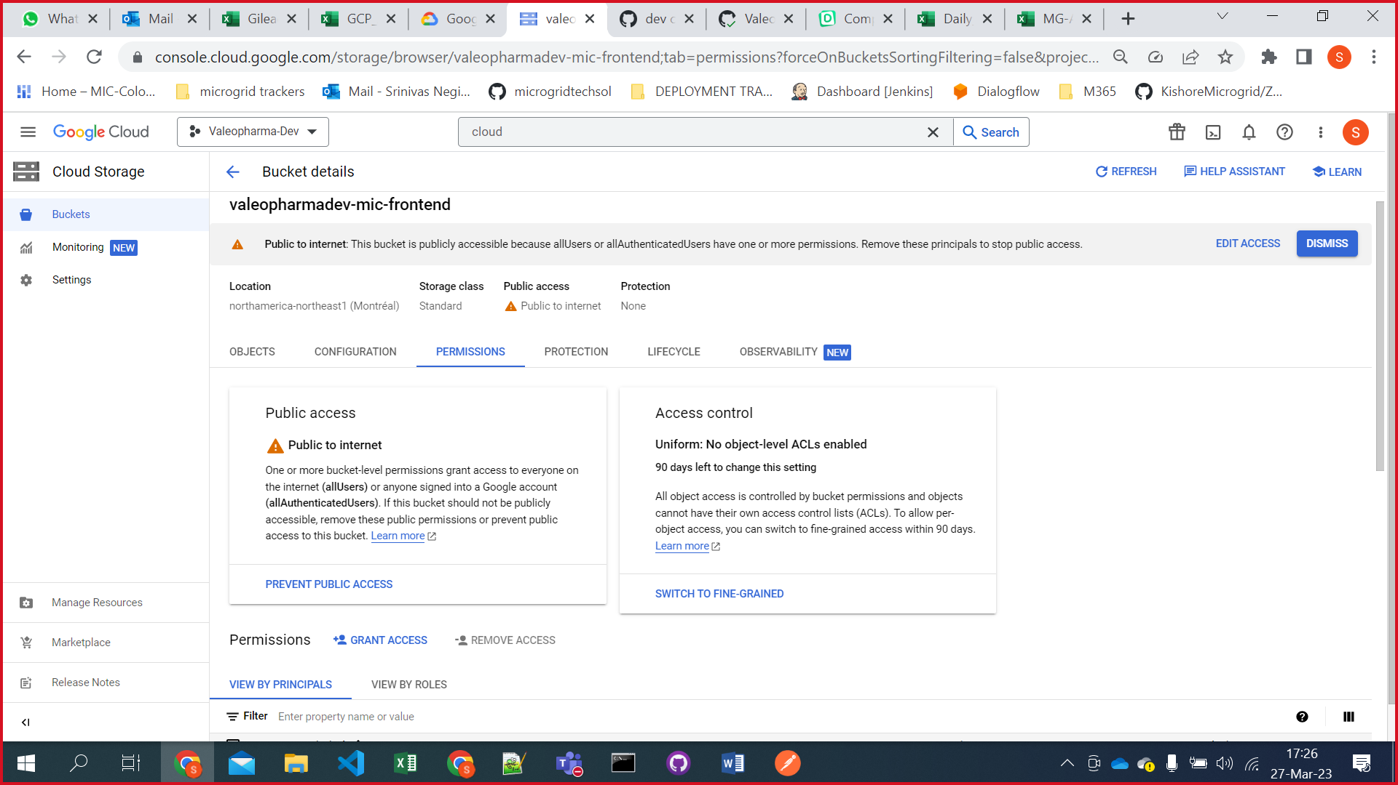

* 1. Later we need to create a service account in IAM.
  2. Go to the IAM section

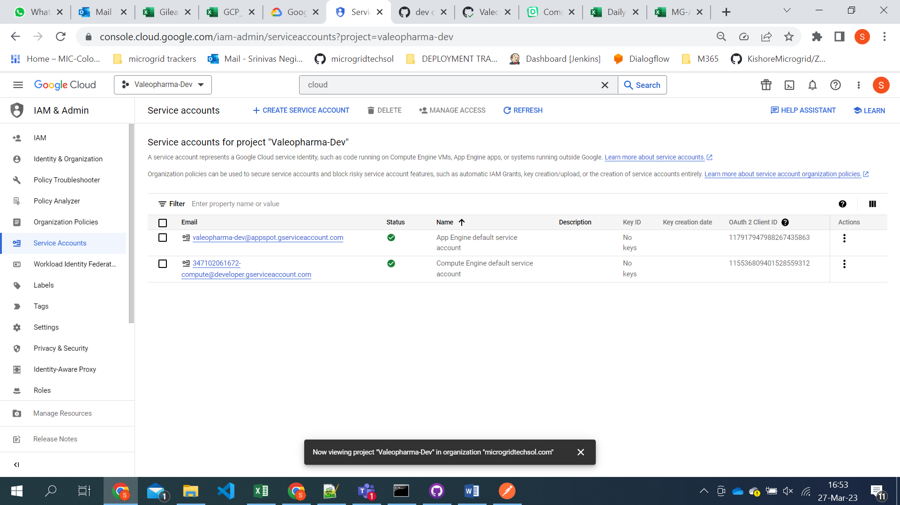

* 1. Click on create service account

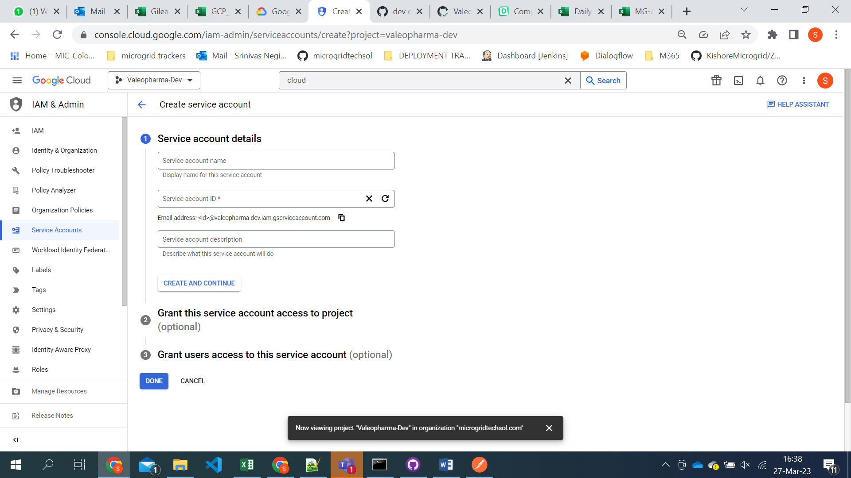

1. **PostgreSQL:**

To enable a PostgreSQL instance in Google Cloud Platform (GCP) using existing backup files, you can follow these steps:

1. Upload backup files to Cloud Storage:
2. Go to the Google Cloud Console (https://console.cloud.google.com) and navigate to the project where you want to create the PostgreSQL instance.
3. In the Cloud Console, click on "Storage" in the sidebar to access the Cloud Storage section.
4. Create a new bucket or select an existing bucket to upload your backup files.
5. Upload the PostgreSQL backup files (e.g., .sql or .dump files) to the selected bucket. You can either use the Cloud Console UI or tools like gsutil or Cloud Storage client libraries to upload the files.
6. Go to the Cloud SQL section:
7. Go back to the Google Cloud Console.
8. In the Cloud Console, click on "SQL" in the sidebar to access the Cloud SQL section.
9. Create a new instance with backups:
10. Click on the "Create instance" button to start the process of creating a new Cloud SQL instance.

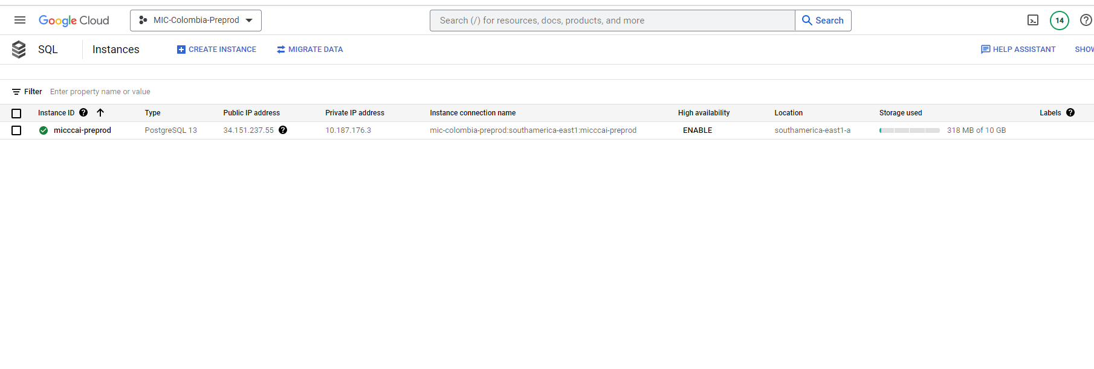

1. In the "Create a database" page, select "PostgreSQL" as the database type.

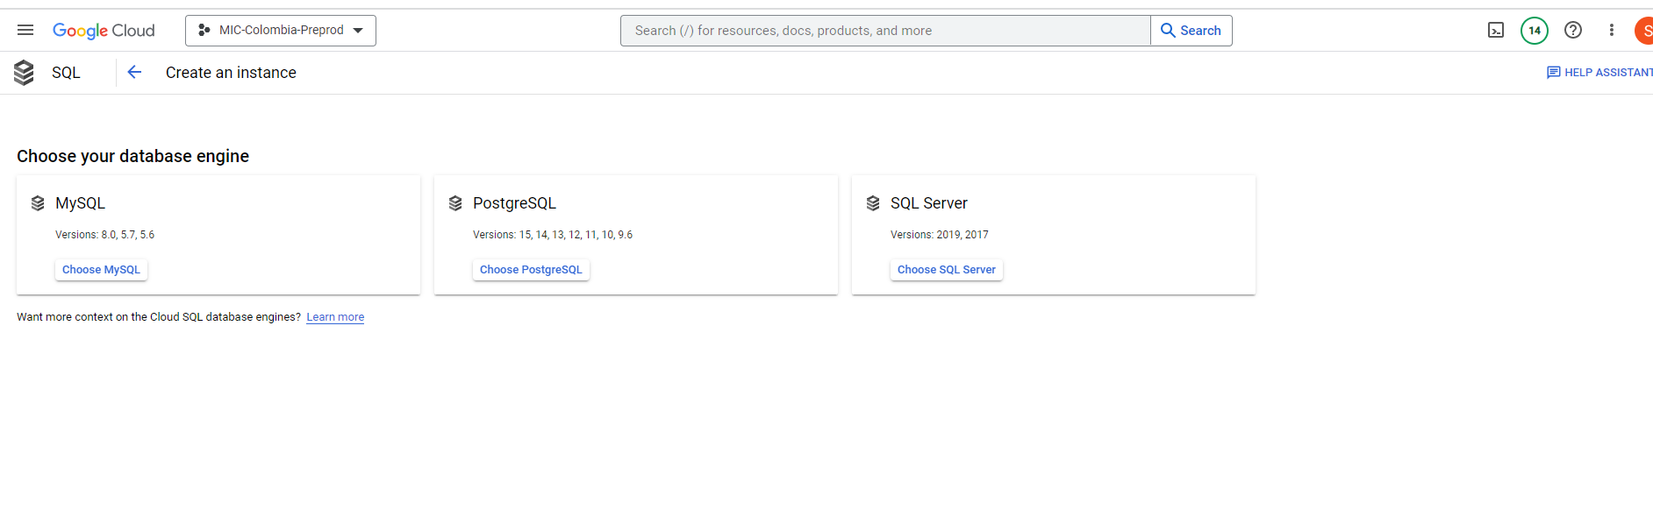

1. Choose the desired instance configuration, region, and other settings based on your requirements.
2. In the "Additional configuration" section, click on the "Backups" tab.
3. Choose the "Import from backup" option.
4. Select the bucket where you uploaded the backup files in step 1.
5. Specify the backup file you want to use.
6. Configure other settings, such as the instance name, password, and connection details.
7. Click on the "Create" button to create the PostgreSQL instance with the selected backup file.
8. Wait for the restore process to complete:

# Disabling services

1. **APIs & Services:**

To disable an API in Google Cloud Platform (GCP), please follow these steps:

1. Go to the GCP Console: <https://console.cloud.google.com/>.
2. Select the project that contains the API you want to disable from the project drop-down menu at the top of the page.
3. In the navigation menu on the left, click on "APIs & Services" and then select "Library" from the sub-menu.
4. In the Library section, you will see a list of available APIs. Use the search bar or scroll through the list to find the API you want to disable.

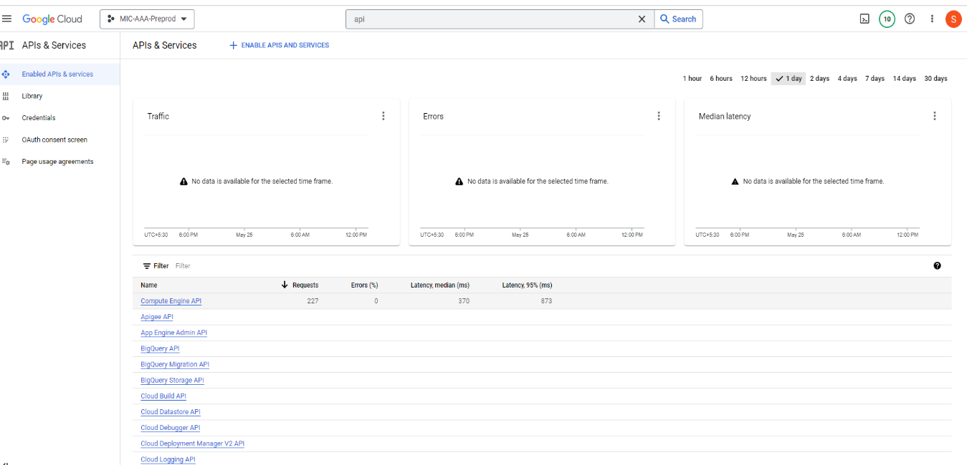

1. Once you locate the API, click on it to open its details page.
2. On the API details page, you will find an "Enable" button indicating that the API is currently enabled. Click on the "Enable" button.
3. In the dialog box that appears, click on the "Disable" button to confirm the action.

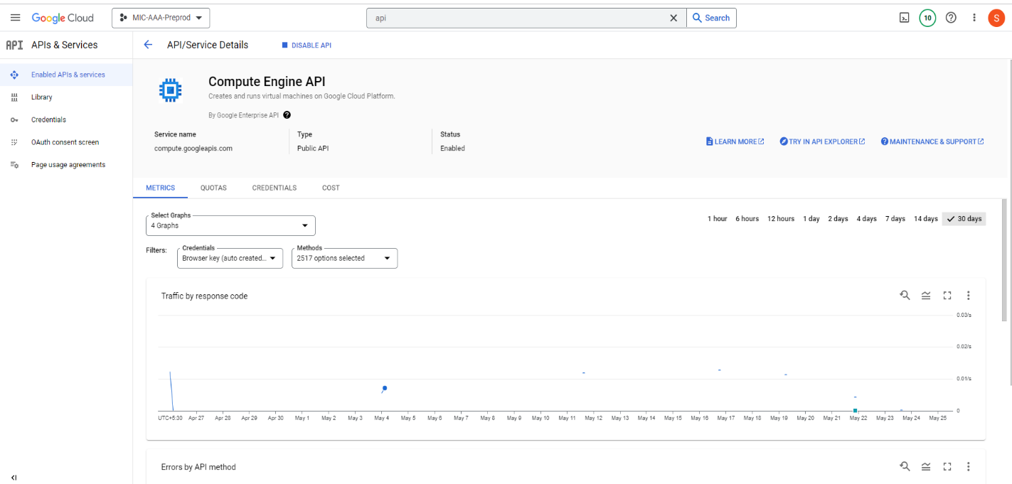

1. **VM INSTANCE:**

To disable VM instances in a project to reduce billing in Google Cloud Platform (GCP), please follow these steps:

1. Go to the GCP Console: <https://console.cloud.google.com/>.
2. Select the project that contains the VM instances you want to disable from the project drop-down menu at the top of the page.
3. In the navigation menu on the left, click on "Compute Engine" under the "Compute" section.
4. On the Compute Engine page, you will see a list of your VM instances.
5. Identify the VM instances you want to disable and select them by clicking the checkboxes next to their names. You can select multiple instances at once if needed.

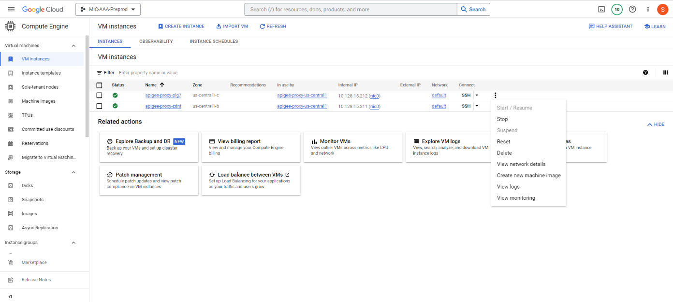

1. Once you have selected the desired instances, click on the "Stop" button at the top of the VM instances list. This will initiate the shutdown process for the selected instances.
2. In the confirmation dialog box that appears, review the details and click on the "Stop" button to confirm the action.
3. **APP ENGINE:**

To disable App Engine services in a project to reduce billing in Google Cloud Platform (GCP), follow these steps:

1. Go to the GCP Console: <https://console.cloud.google.com/>.
2. Select the project that contains the App Engine services you want to disable from the project drop-down menu at the top of the page.
3. In the navigation menu on the left, click on "App Engine."
4. On the App Engine page, you will see a list of your App Engine services.
5. Identify the App Engine service you want to disable and select it by clicking on its name.

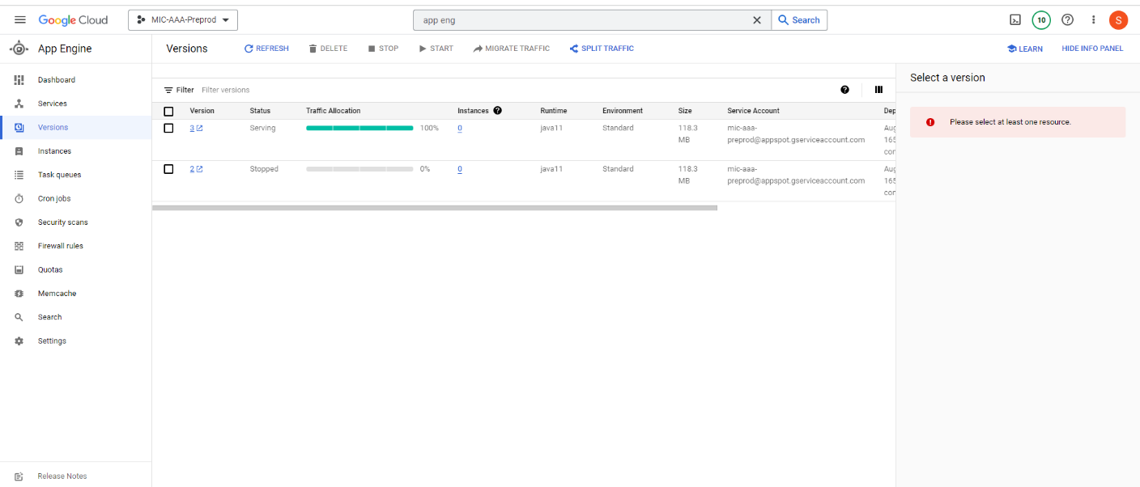

1. Once you are on the service's page, click on the "Stop" button at the top of the page. This will initiate the process of disabling the App Engine service.
2. If you want to delete the service click on delete.

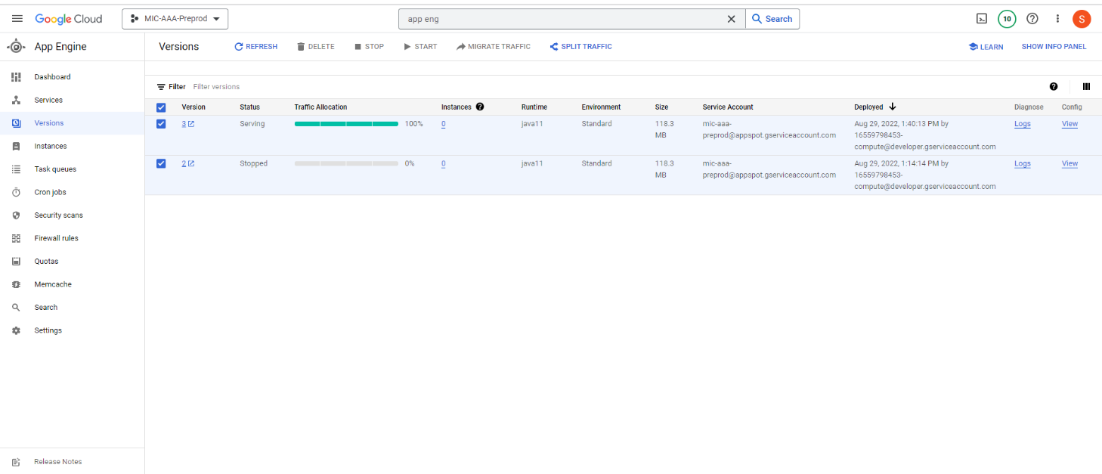

1. **CLOUD STORAGE BUCKET:**

To disable cloud storage sources for a project in Google Cloud Platform (GCP) and reduce billing, Please follow these steps:

1. Go to the Google Cloud Console: <https://console.cloud.google.com/>
2. Select your project from the project selector dropdown at the top of the page.
3. Open the Storage menu from the left navigation panel and select "Browser."
4. In the Storage Browser, you will see a list of buckets associated with your project. Select the bucket(s) you want to disable.
5. Click the "Delete" button at the top of the page to delete the selected bucket(s).

**Note:** Deleting a bucket will also delete all objects stored within it, so make sure you have a backup if needed.

1. Confirm the deletion when prompted.

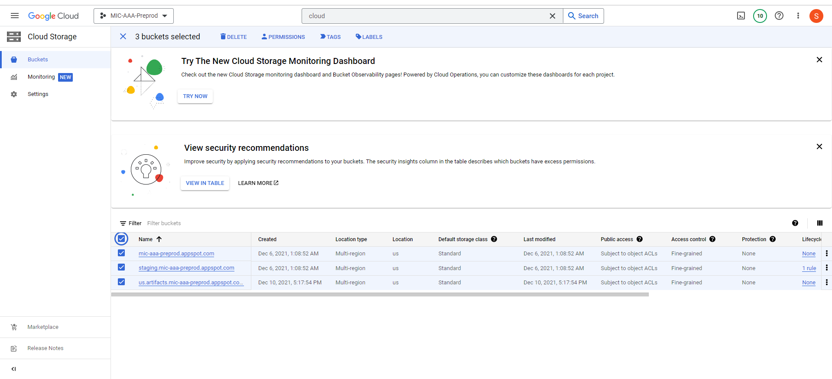

1. **CLOUD FUNCTIONS:**

To disable Cloud Functions for a project in Google Cloud Platform (GCP) and reduce billing, please follow these steps:

1. Go to the Google Cloud Console: <https://console.cloud.google.com/>
2. Select your project from the project selector dropdown at the top of the page.
3. Open the Cloud Functions menu from the left navigation panel.
4. In the Cloud Functions page, you will see a list of all the functions deployed in your project.
5. Identify the functions you want to disable and click on the checkbox next to each function.
6. Once you have selected the functions, click on the "Disable" button at the top of the page.
7. Confirm the disable operation when prompted.

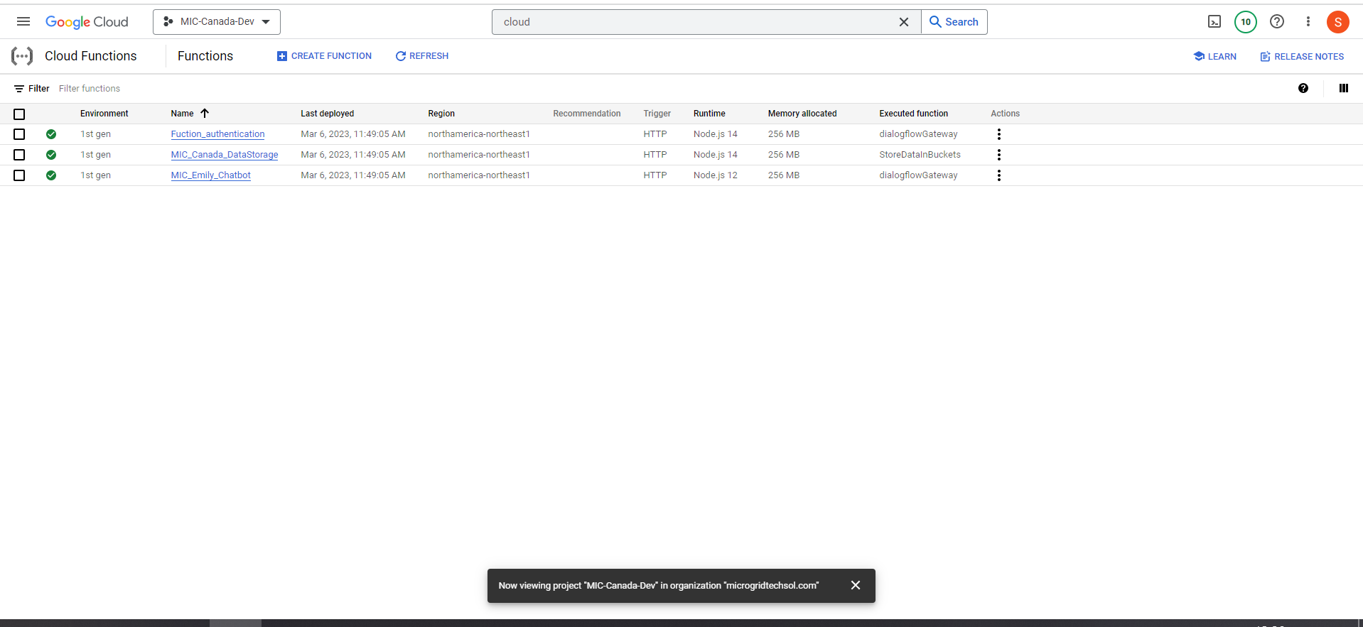

1. **PostgreSQL:**

To disable PostgreSQL instances for a project in Google Cloud Platform (GCP) and reduce billing, you can follow these steps:

1. Go to the Google Cloud Console: <https://console.cloud.google.com/>
2. Select your project from the project selector dropdown at the top of the page.
3. Open the Cloud SQL menu from the left navigation panel.
4. In the Cloud SQL page, you will see a list of your database instances.
5. Identify the PostgreSQL instance you want to disable and click on it.

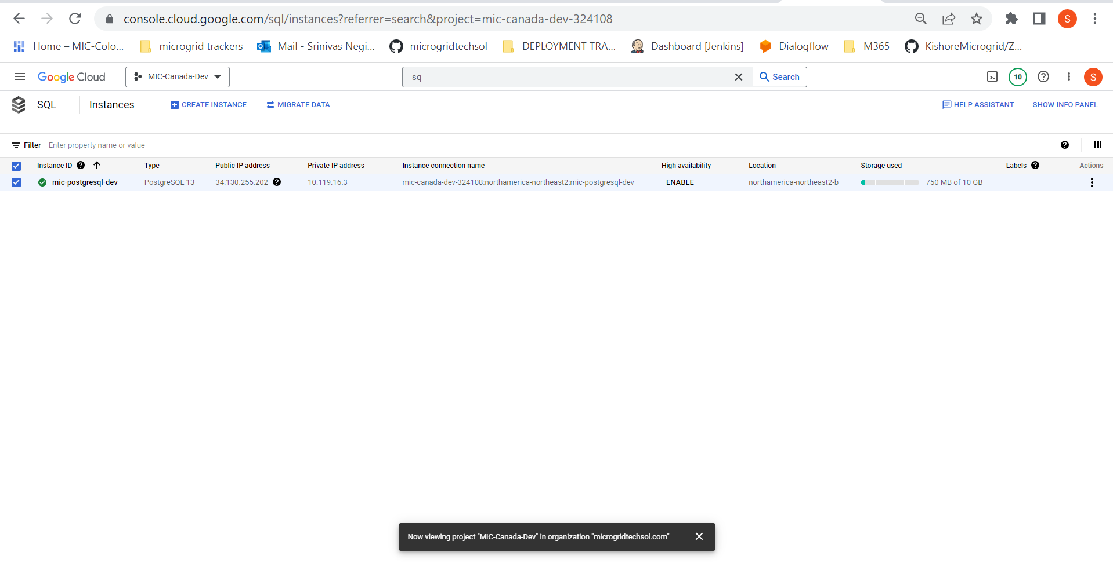

1. In the instance details page, click on the "Delete" button at the top of the page.
2. Confirm the deletion when prompted.

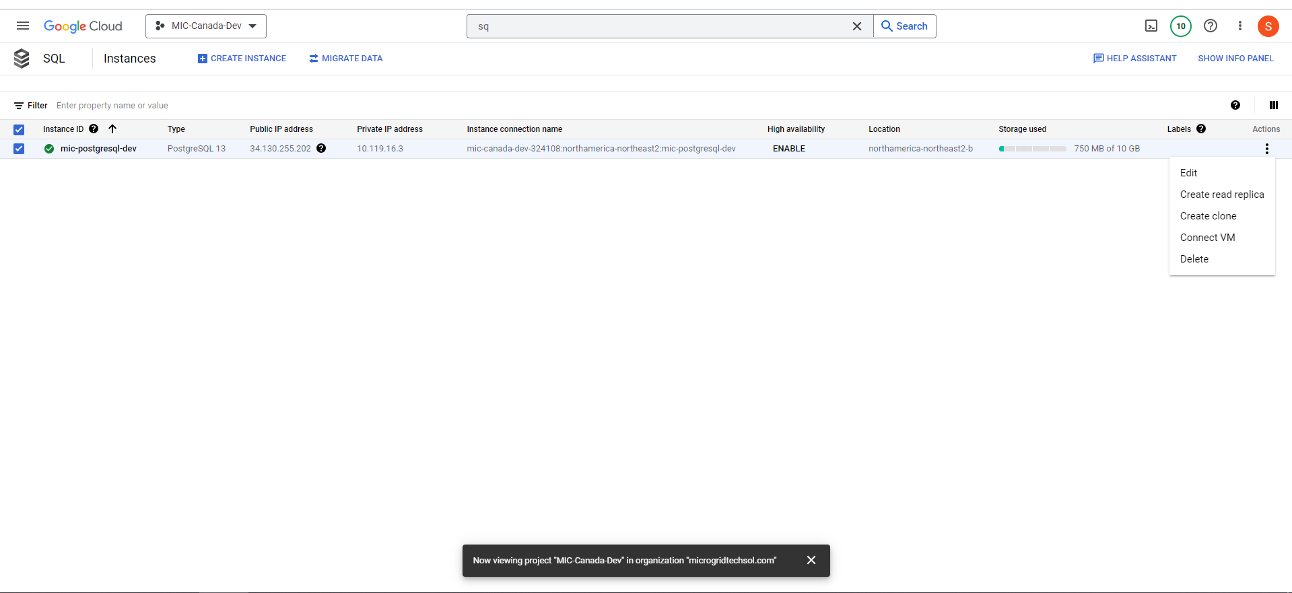

|  |  |
| --- | --- |
| **Name** | **Contact** |
| Srinivas Negi | [srinivasa.n@microgridtechsol.com](mailto:srinivasa.n@microgridtechsol.com) |